**[ NOT WORKING ]**

Create a project by using below command:

**npx create-react-app** reactredux

where reactredux is project name

*****************************************

goto inside project location by command in vs code and install redux by using below command:

**npm i redux react-redux**

create two folders **actions** and **reducers** inside src folder, than create a file **index.js** inside actions folder , than create 2 files **index.js** and **upDown.js** inside reducers folder (we can create multiple reducers).

Create a new file **store.js** inside src folder.

Below version is used in app

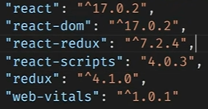

Create below ui by using below code in app.js file:

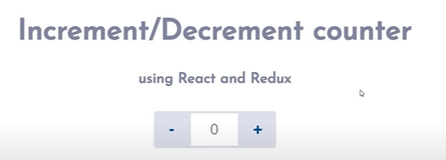

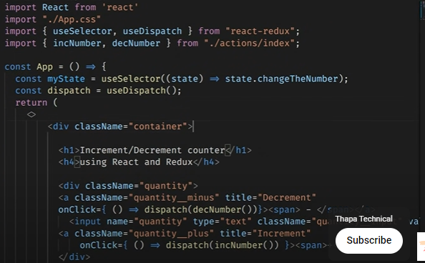

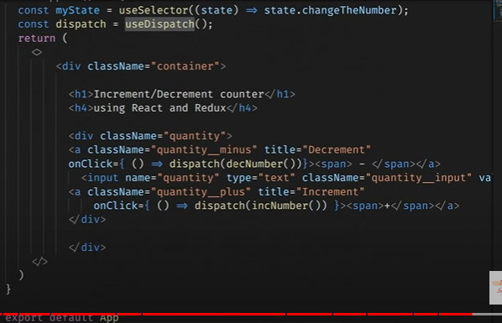

Both are code of one page appp.js

Use className instead of class

Open index.js file of actions folder and paste below code:

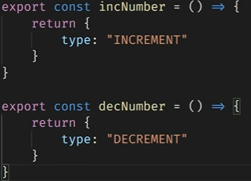

Open upDown.js file of reducers folder and paste below codes:

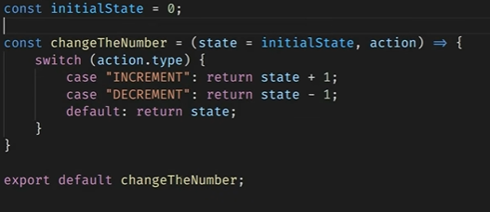

Open index.js file of reducers folder and paste below codes:

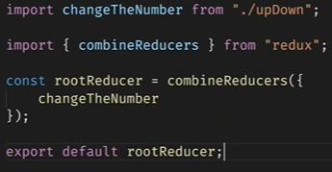

Open store.js file and paste below codes:

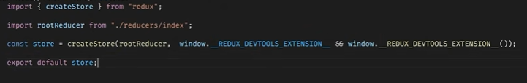

Open index.js file of root location and replace below code:

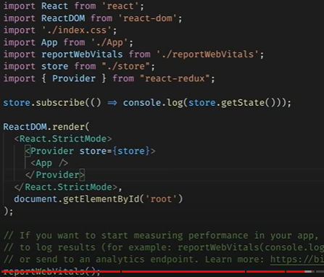

Than check on browser.